**Sitraffic smartTL Connect**

[Catchy phrase associated with the product]

**Ideally, any traffic controller would speak with any central system.**

- With Siemens Sitraffic smartTL Connect it is now possible to connect virtually any third party controller with Siemens Sitraffic smartGuard, our cloud based traffic control center.

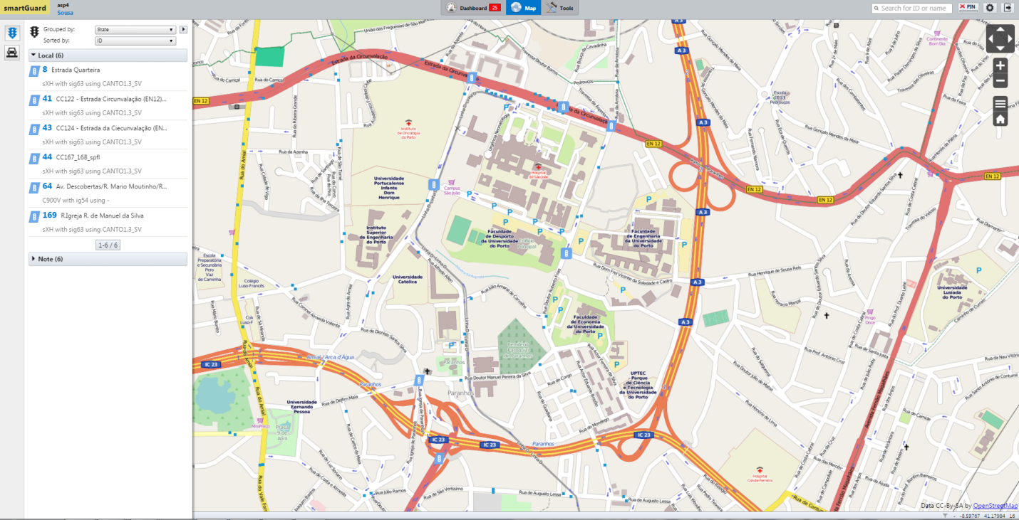

[SmartGuard Interface screenshot]

With the advantages that smartGuard offers.

Sittrafic smartTL Connect allows you, through smartGuard, to monitor and control your field devices regardless of the manufacturer offering operational basic functionalities such as:

Monitor Controller’s state:

* Normal mode;
* Safety mode;
* Offline;
* Power-off mode.

Control Features:

* Change between operational modes (normal and safety);
* Remote reset.

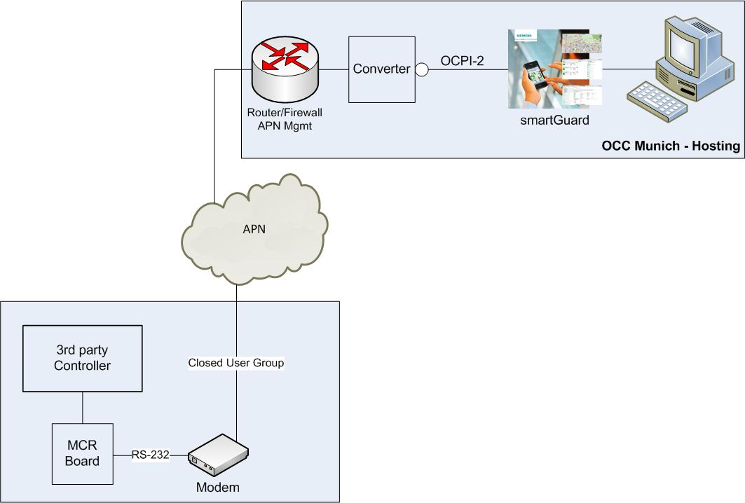

[System Architecture Picture]

Sitraffic smartTL Connect System Architecture - Our device (MCR module) allows bidirectional communication between smartGuard and third party controllers, through a secured mobile network connection connection (GPRS/3G/4G).

Simple installation, as easy as plug & play.

Unobtrusive functionality does not interfere with the controller's normal operation.

Some control features might be limited depending on the controller's model.

Possible applications:

* Support to surveying processes, providing visibility on the operational performance of the installed base;
* Quickly deployment of Sitraffic smartGuard with already existing infrastructure;
* Enables immediate monitor and control features, while replacing older field devices.